Task-2

Github profile:
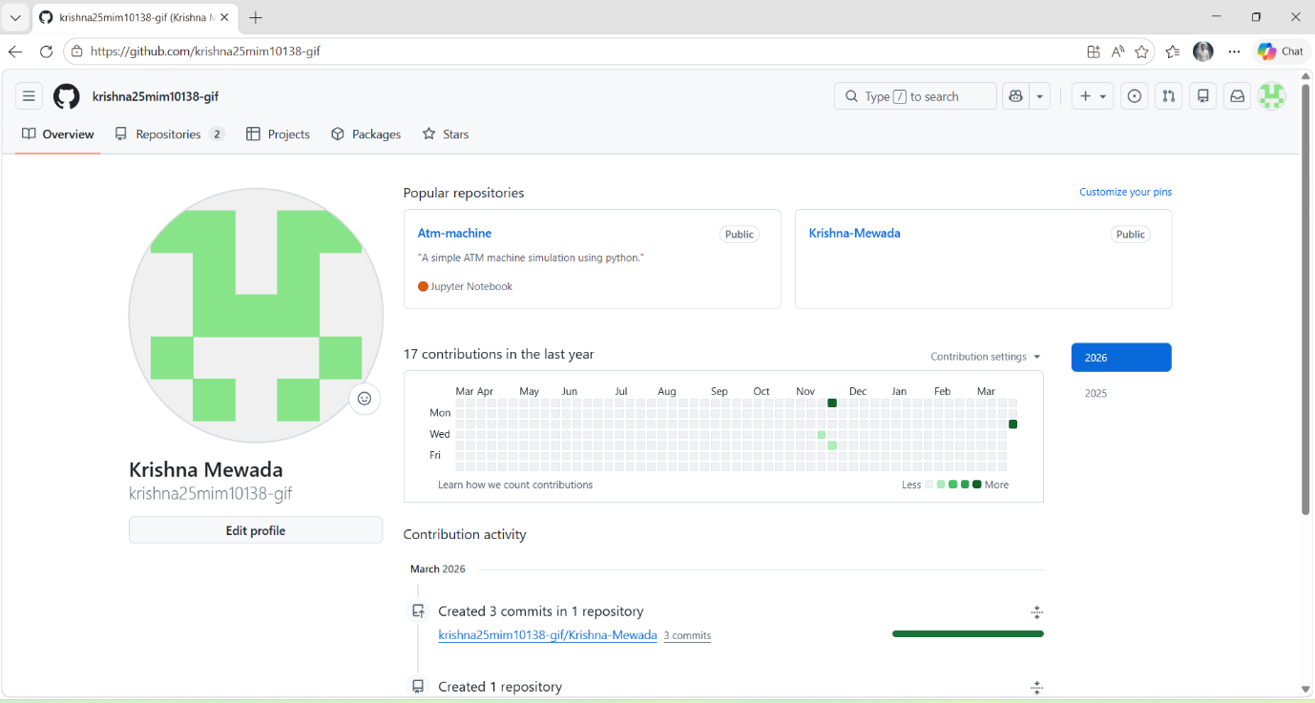

Github respository link:
krishna25mim10138-gif/Krishna-Mewada

Linkdin profile:
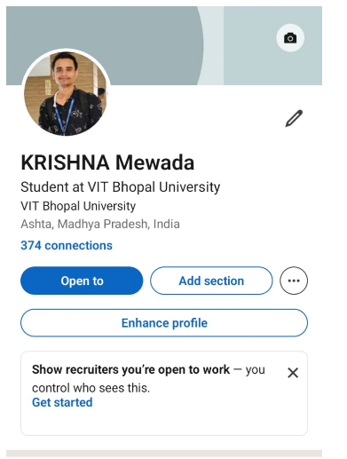

Kaggle profile:
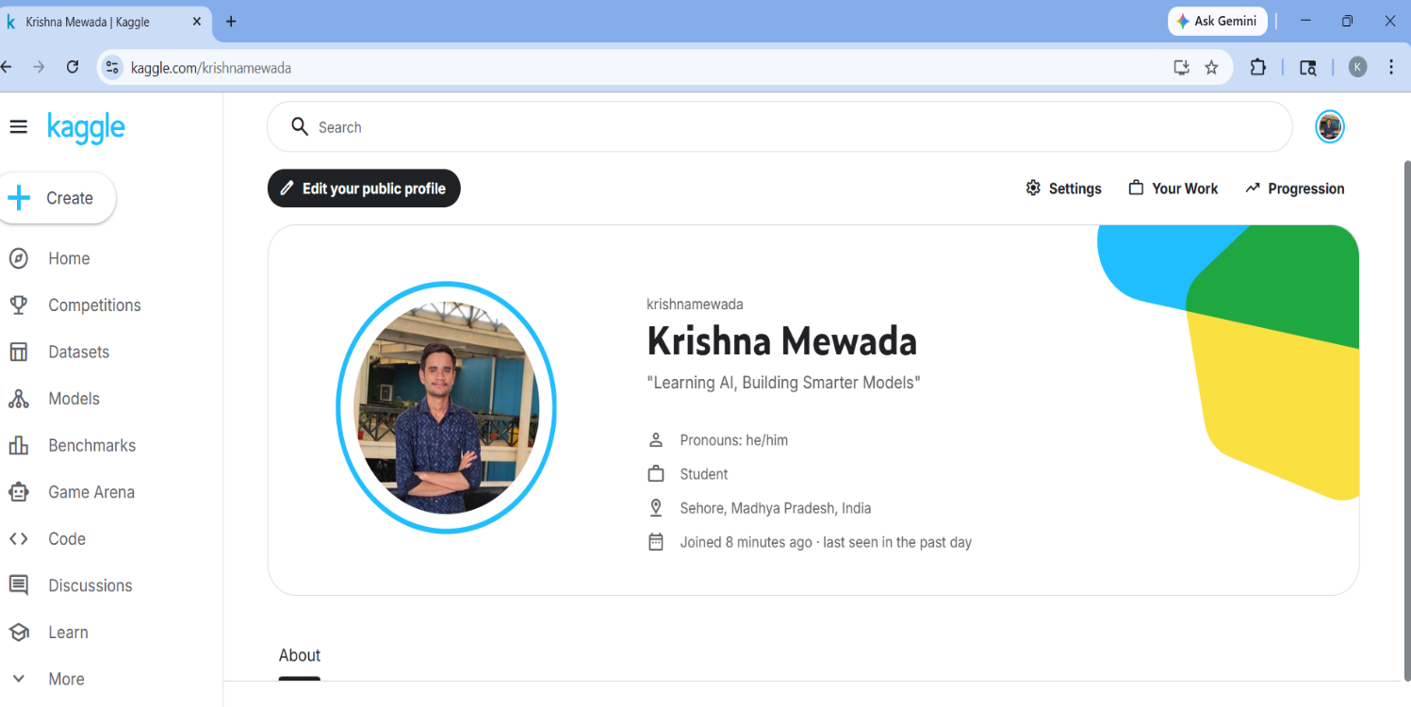
Project Report
For this task, I chose to create and update my profiles on GitHub, LinkedIn, and Kaggle. Each of these platforms plays a unique role in my academic and professional journey.
On GitHub, I set up a profile README that introduces my name, branch, year, and my learning goals. GitHub is primarily used for hosting code, collaborating on projects, and showcasing technical skills. Over the next four years, I plan to use it as a portfolio of my programming work, including assignments, personal projects, and open-source contributions.
On LinkedIn, I updated my Education section with my current degree, institution, and expected graduation year. LinkedIn is a professional networking platform where students and professionals connect, share achievements, and explore career opportunities. I intend to use it to build connections with peers, alumni, and industry experts, while also highlighting internships and certifications.
On Kaggle, I created a profile to participate in data science competitions and access datasets. Kaggle is widely used for machine learning practice and collaborative problem-solving. I plan to use it to strengthen my skills in data analysis and AI, while learning from the global community.
Together, these platforms will help me grow academically, professionally, and technically throughout my degree.

